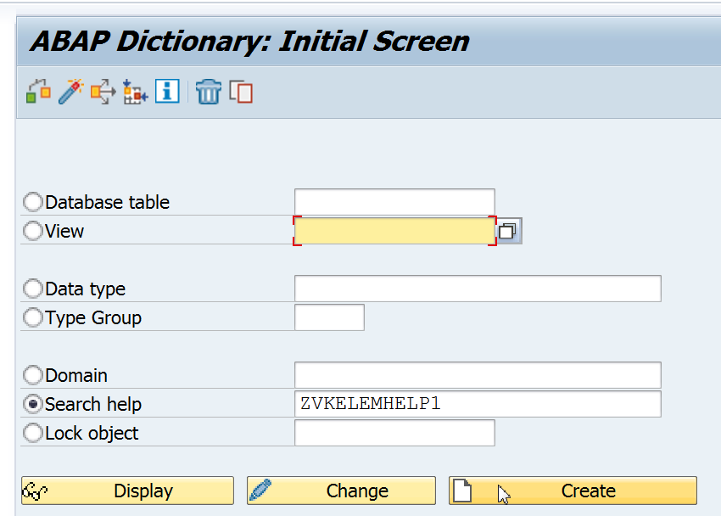

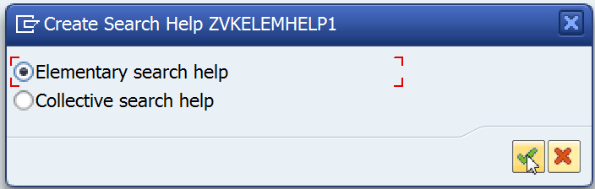

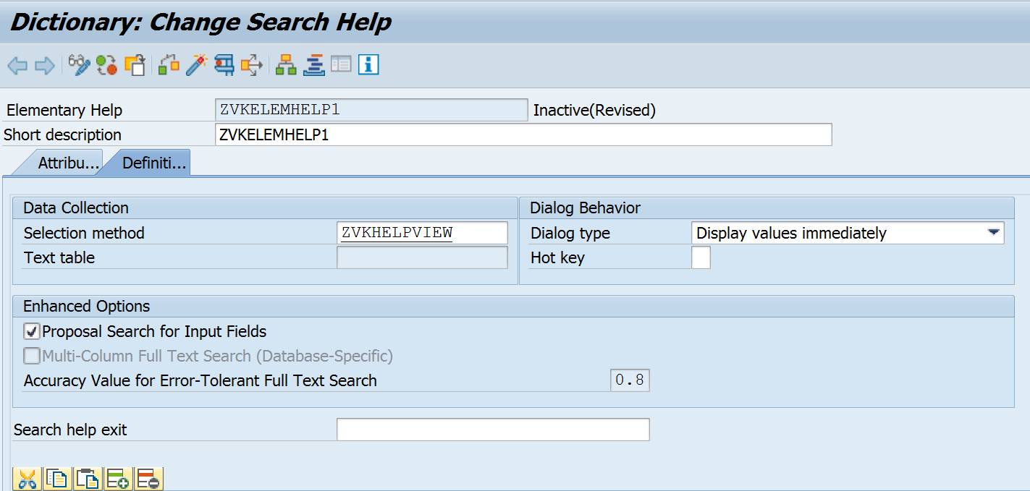

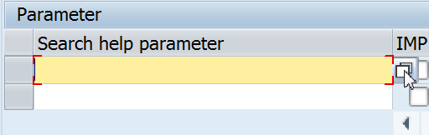

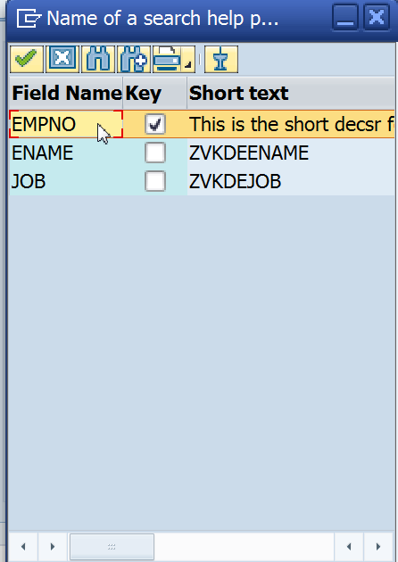

Double Click to Select.



Export is to export from Database to HitList.

Import is when you select the field values and display.

LPOS is List position i.e position of the Field on the Hit List.

Activate and test.

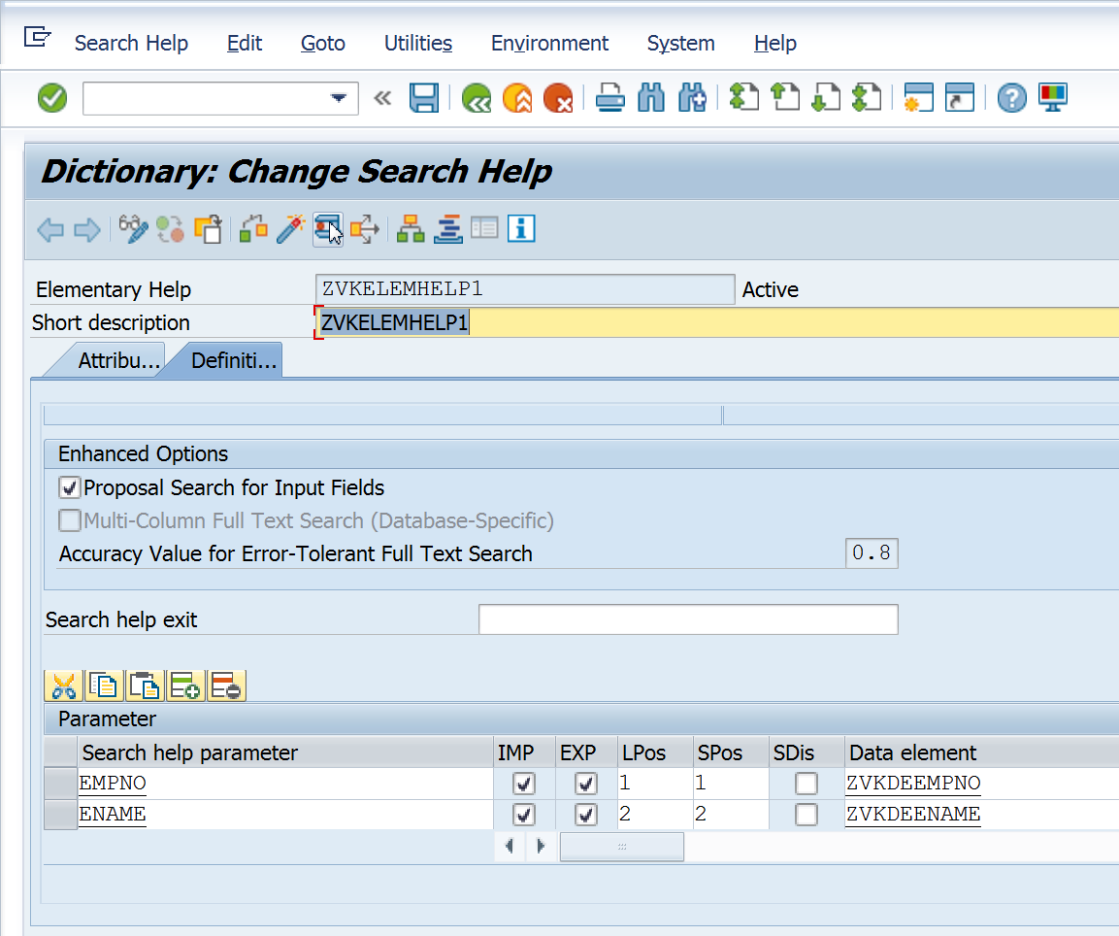

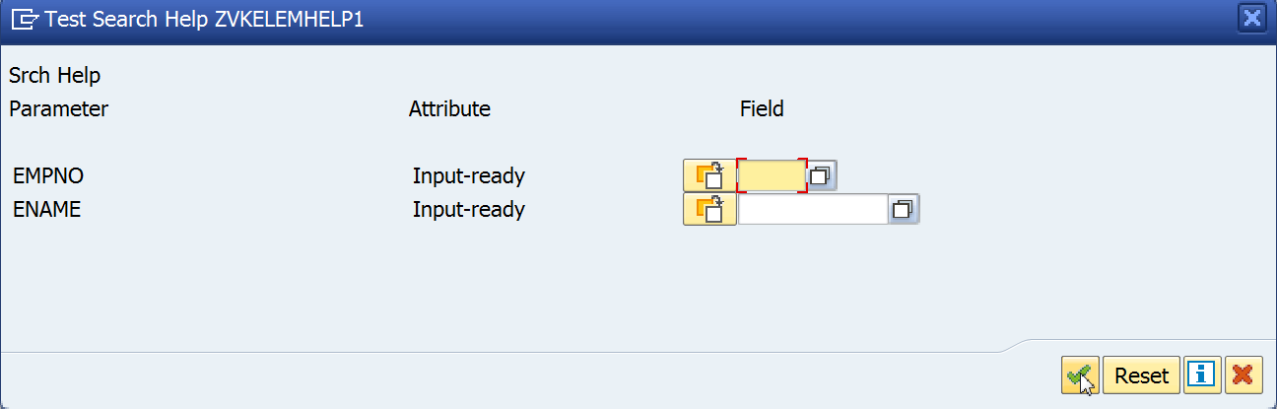

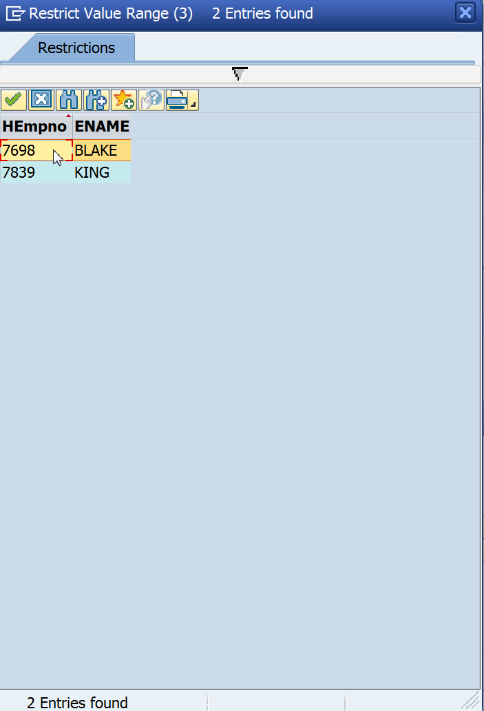

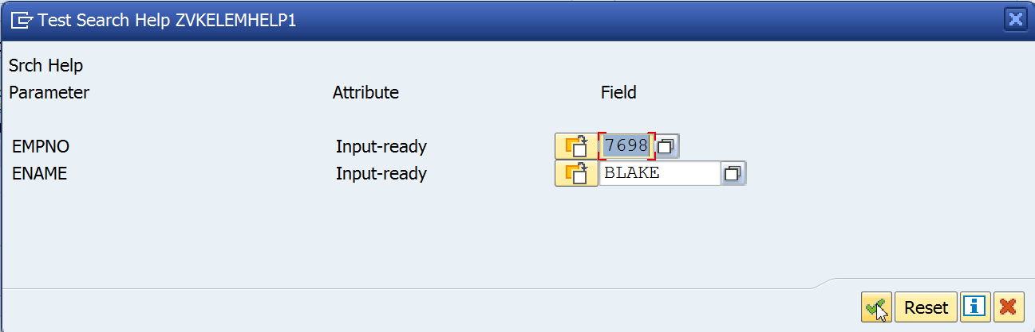

_____________________________________________________________________________________

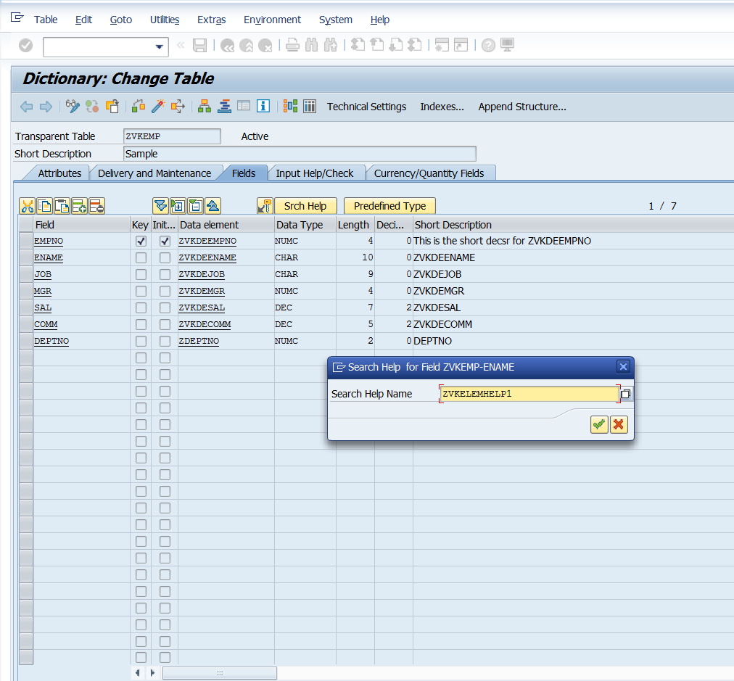

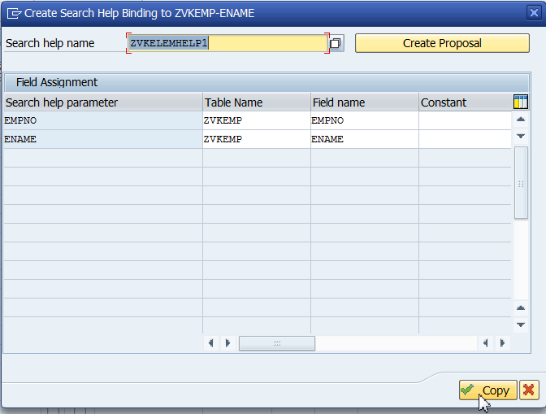

Save and activate the table.

When you add entries in Emp table, It will show search help for field ename. It shows a search icon which can be clicked to see the search help.